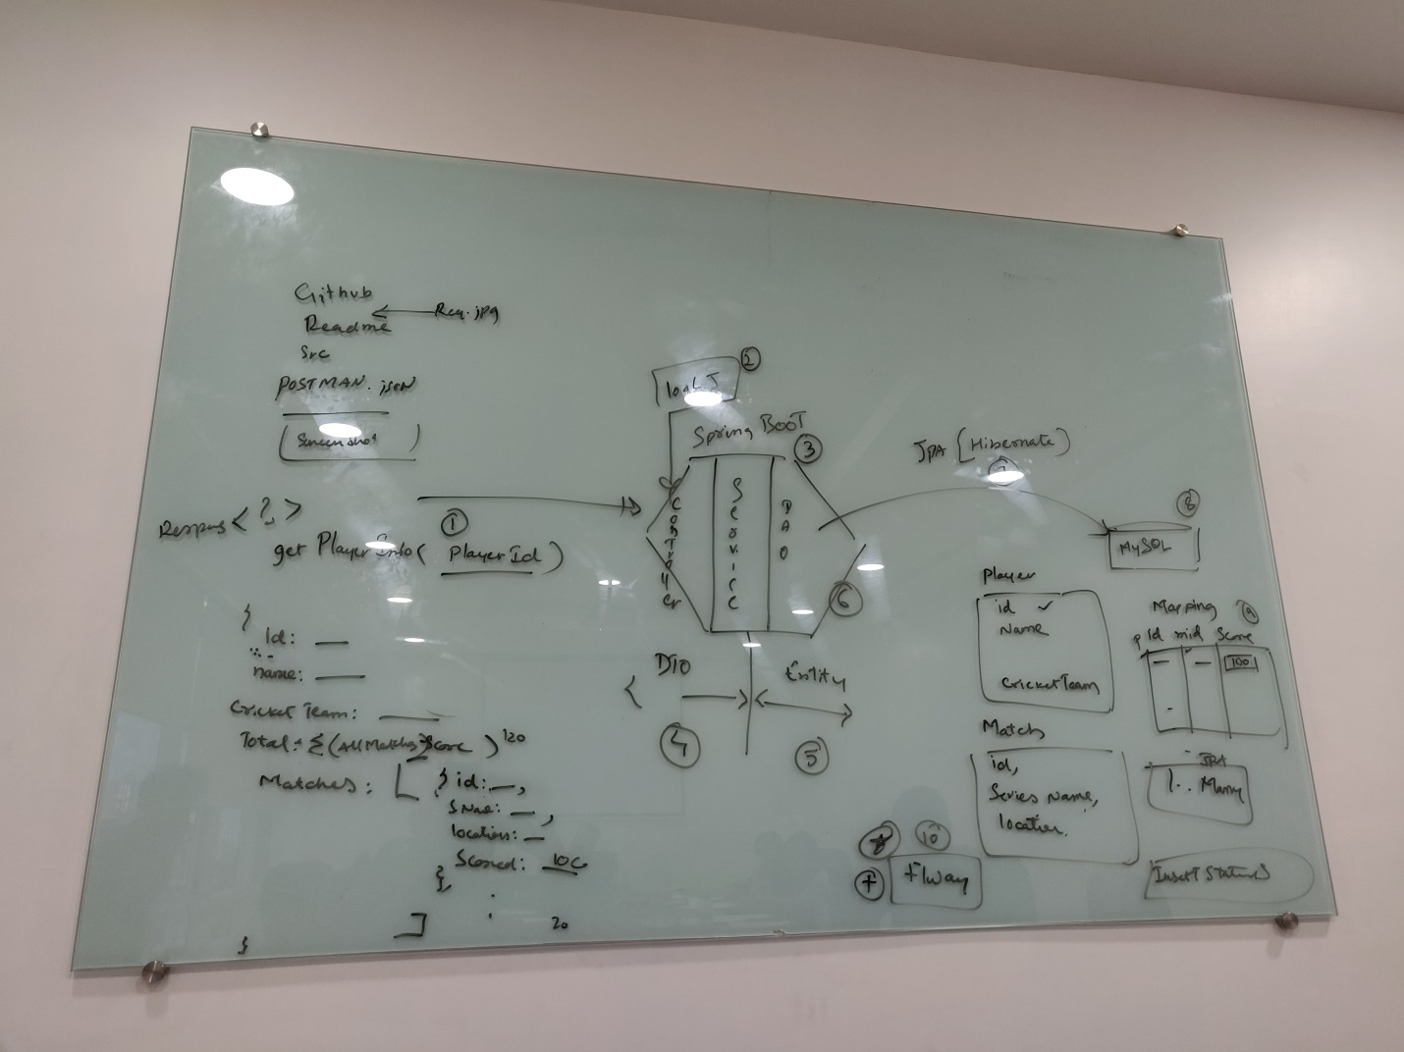**PROBLEM STATEMENT:-**

There will a table **PLAYER** which will have player details and a table **MATCH** which will have match details. A join table which will contain the **score , player_id and match_id** which will tell the runs each player scored in a particular match.   
  
The insert statements in the table can be performed by **FLYWAY.  
  
RESULT:-**On asking for a particular player details using his/her id , we should get a json response which will contain the following details :-   
playerID , playerName , cricketTeam, total-score(total sum of scores in all matches played by him/her) , match details(it will be an array which will give the match details that the particular player played)